**Online Shopping**

Online customer can browse or search items, view specific item, add it to shopping cart, view and update shopping cart, checkout. User can view shopping cart at any time. Checkout is assumed to include user registration and login.

This example does not use partitions, most of the actions are assumed to be fulfilled by online customer.

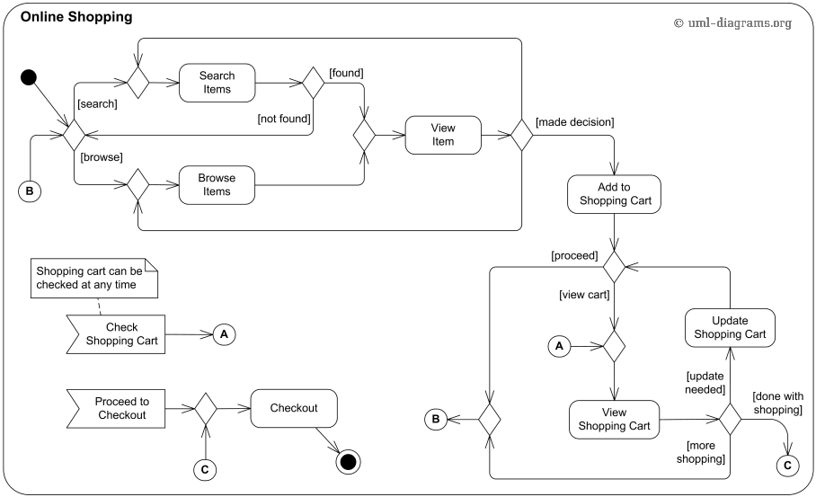

# Ticket Vending Machine

Ticket vending machine will request trip information from Commuter. This information will include number and type of tickets, e.g. whether it is a monthly pass, one way or round ticket, route number, destination or zone number, etc.

Based on the provided trip info ticket vending machine will calculate payment due and request payment options. Those options include payment by cash, or by credit or debit card. If payment by card was selected by Commuter, another actor, Bank will participate in the activity by authorizing the payment.

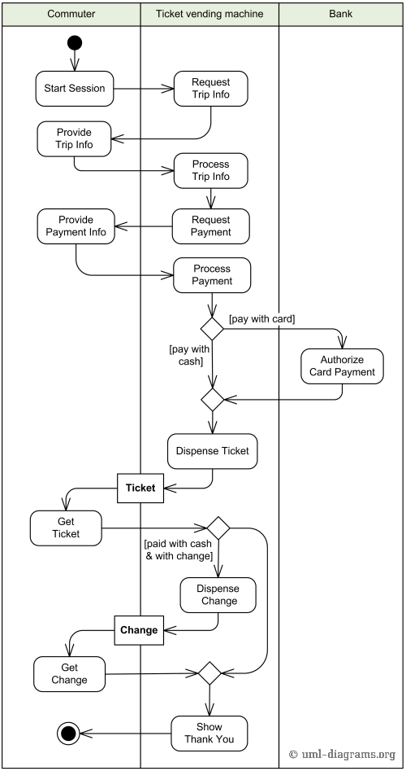

# Process Shopping Order

Requested order is input parameter of the activity. After order is accepted and all required information is filled in, payment is accepted and order is shipped. Note, that this business flow allows order shipment before invoice is sent or payment is confirmed.

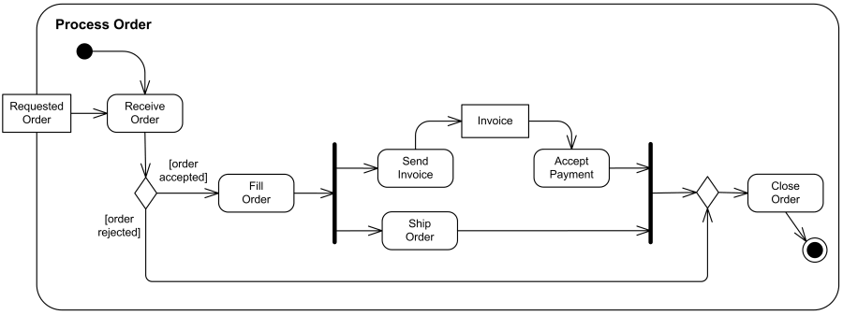

# Document Management Process

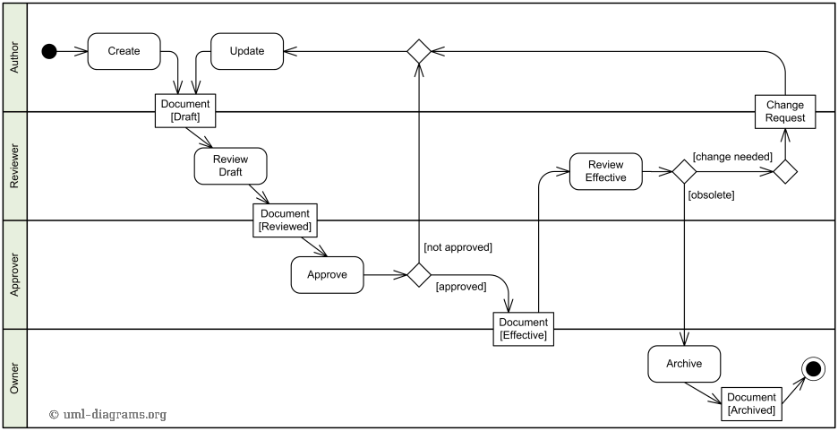

# Resolve Software Issue

An example of **UML activity diagram** which shows how to resolve an issue in a software design. After ticket is created by some authority and the issue is reproduced, issue is identified, resolution is determined, issue is fixed and verified, and ticket is closed, if issue was resolved.

This example does not use partitions, so it is not very clear who is responsible for fulfilling each specific action.

